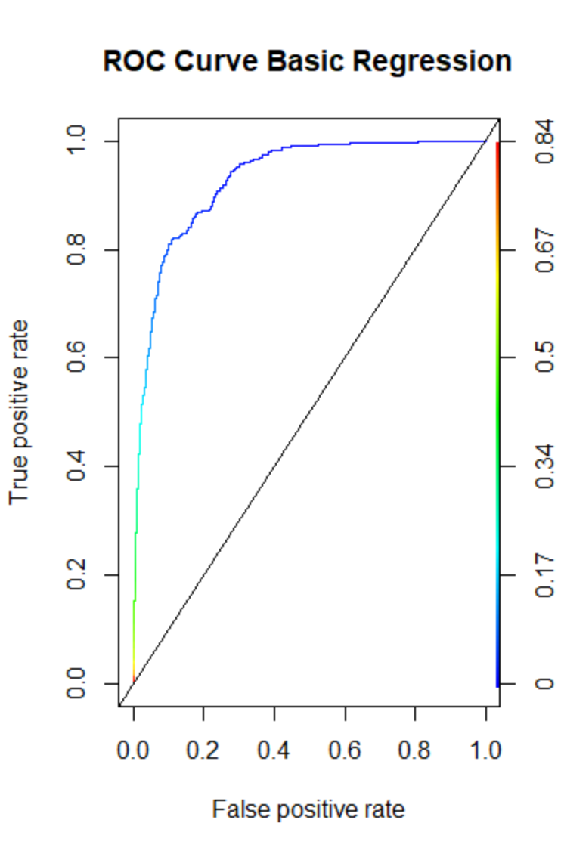 W/Outliers

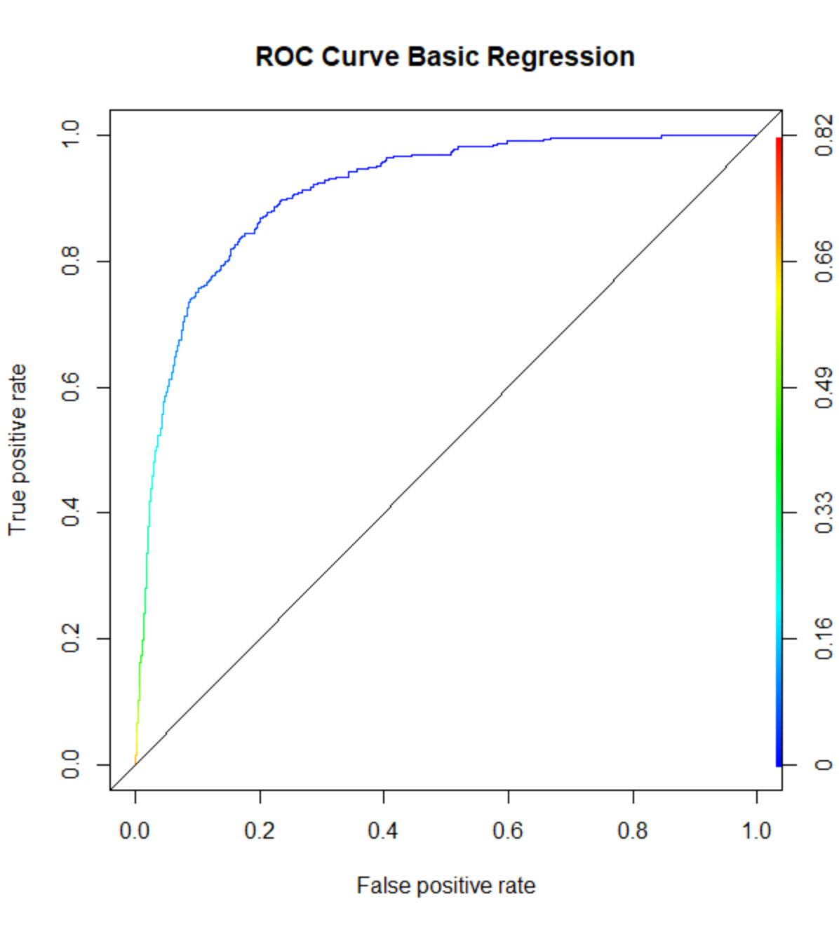

W/o Outliers

Basic Regression

|  |  |  |
| --- | --- | --- |
| Score | W/ Outliers | W/o Outliers |
| Accuracy | 0.9708768 | 0.9611691 |
| truePos | 0.220339 | 0.1891892 |
| falsePos | 0.005538986 | 0.0113369 |
| AUC | 0.9283295 | 0.9109952 |

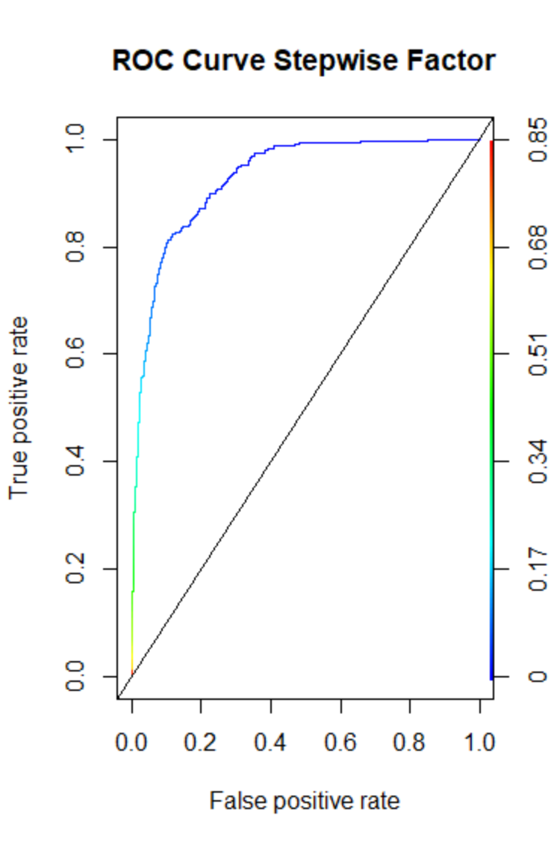

W/ Outliers

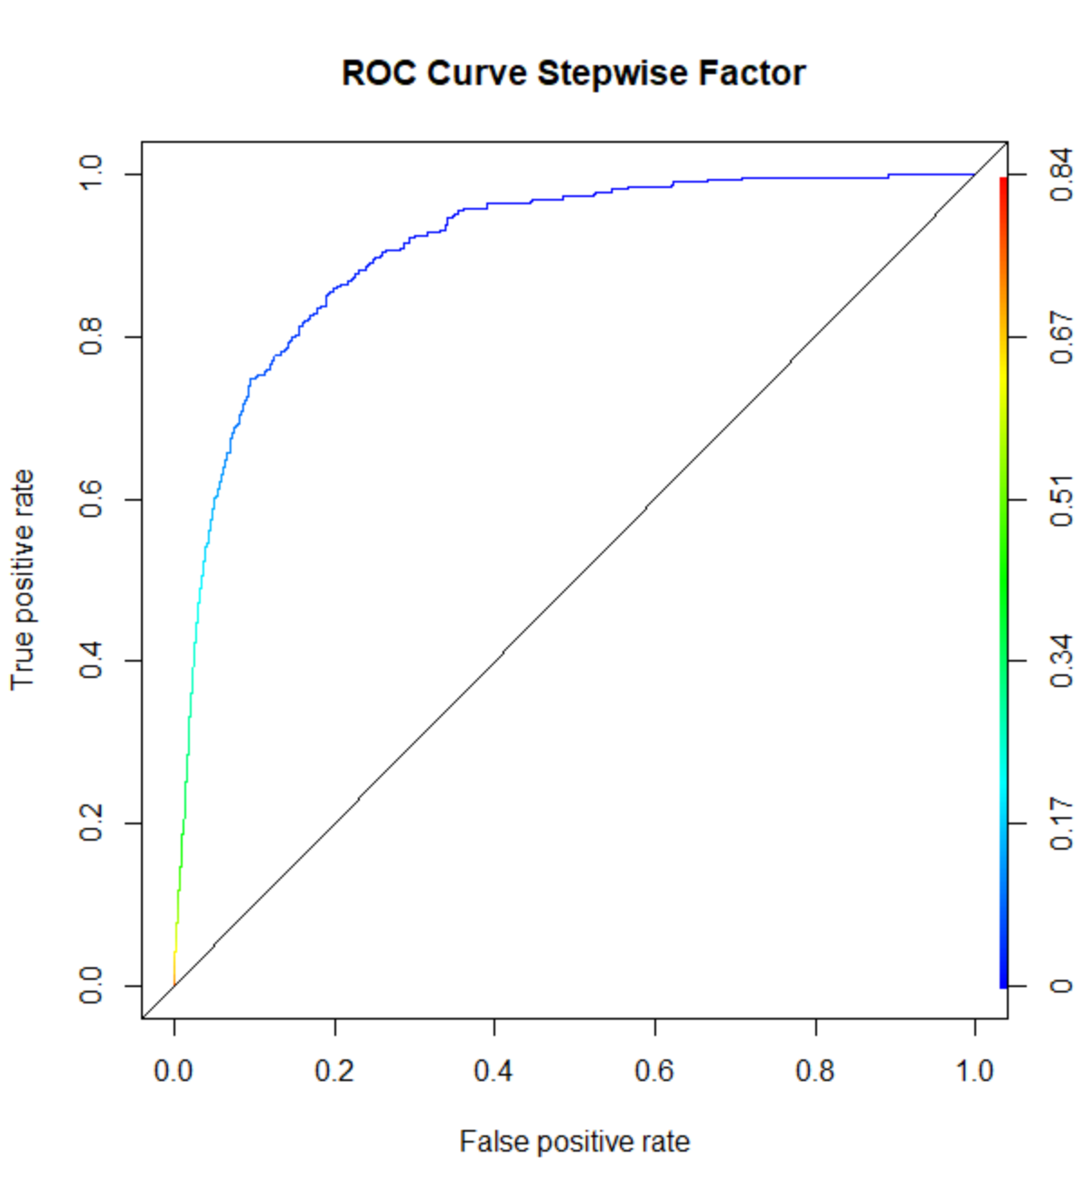

W/o Outliers

Stepwise factor

|  |  |  |
| --- | --- | --- |
| Score | W/ Outliers | W/o Outliers |
| Accuracy | 0.9702572 | 0.9620985 |
| truePos | 0.2135593 | 0.1921922 |
| falsePos | 0.005965062 | 0.01048128 |
| AUC | 0.9273478 | 0.9092194 |

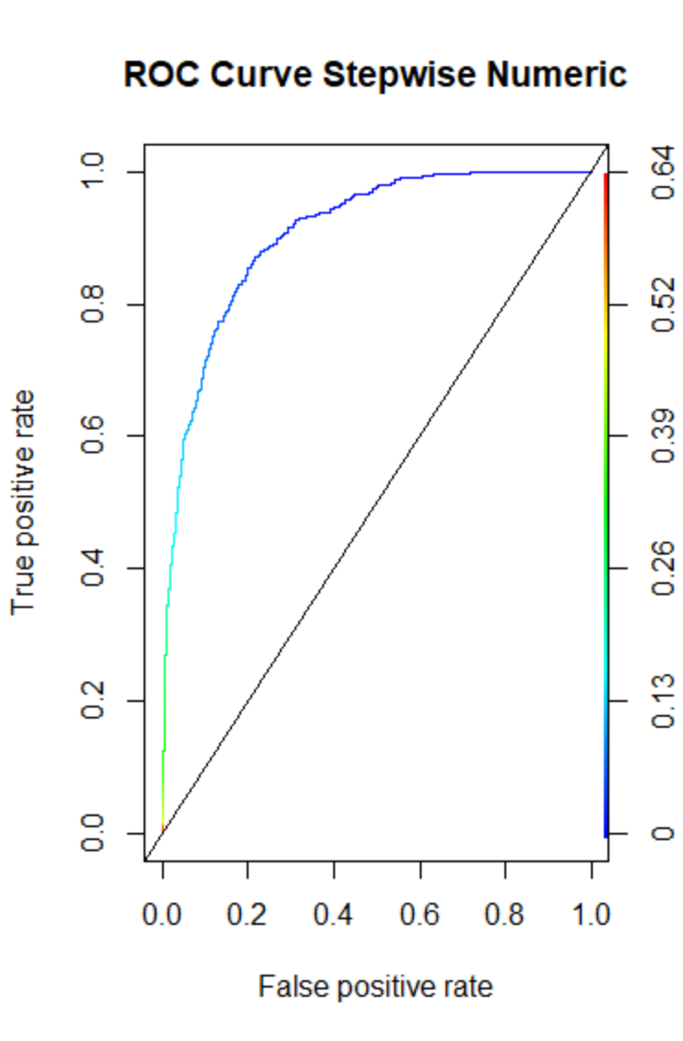

W/ Outliers

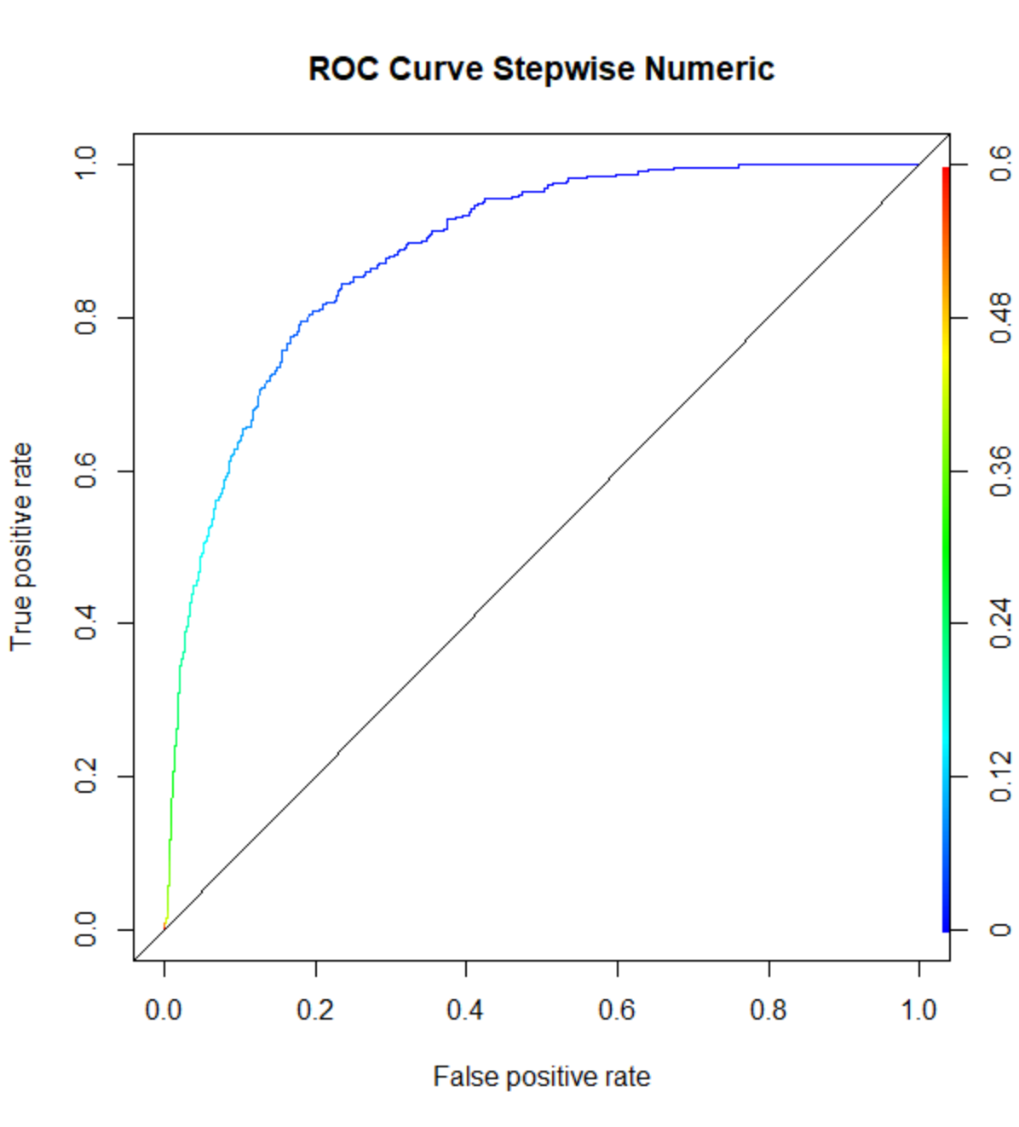

W/o Outliers

AUC Stepwise numeric

|  |  |  |
| --- | --- | --- |
| Score | W/ Outliers | W/o Outliers |
| Accuracy | 0.969431 | 0.9626149 |
| truePos | 0.05762712 | 0.02702703 |
| falsePos | 0.001917341 | 0.004064171 |
| AUC | 0.9066414 | 0.8855246 |

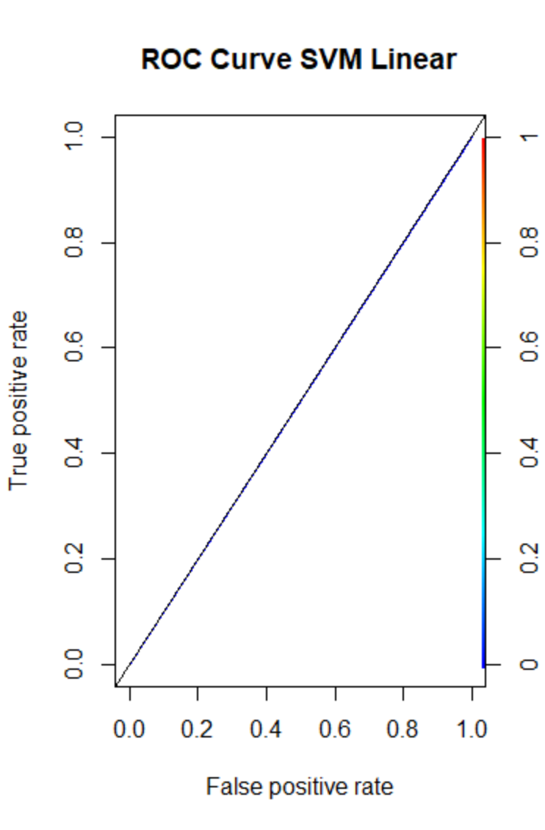

W/ Outliers

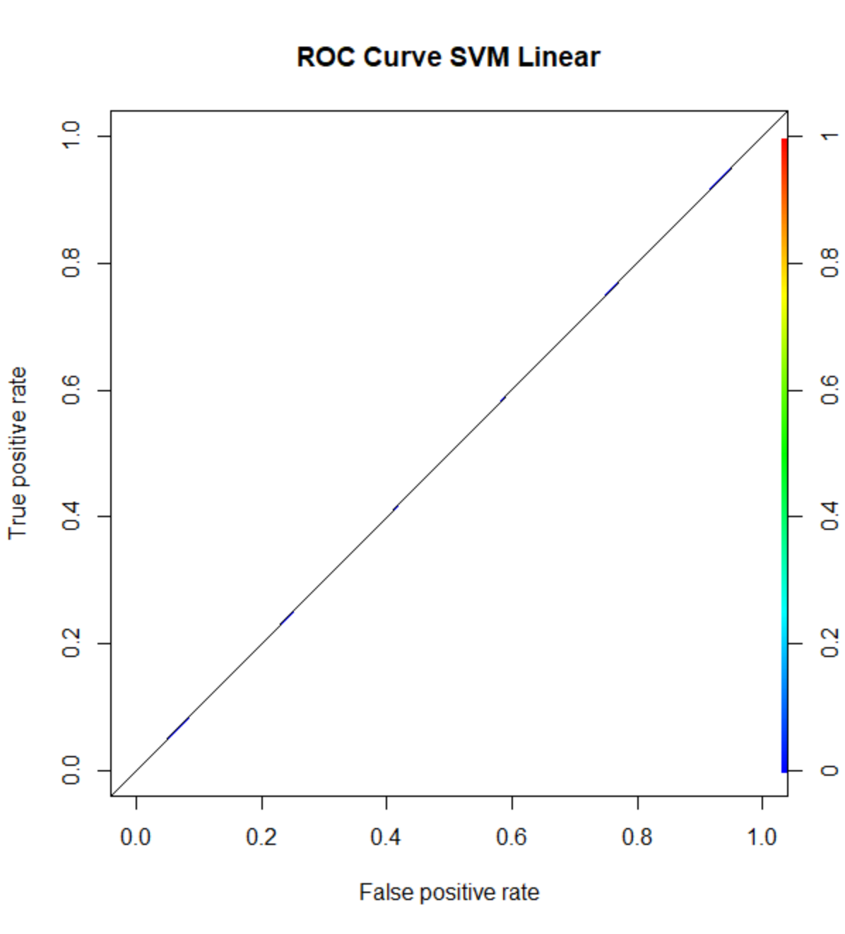

W/o Outliers

AUC for SVML 0.5

|  |  |  |
| --- | --- | --- |
| Score | W/ Outliers | W/o Outliers |
| Train Error | 0.03053503 | 0.03438966 |
| Test Error | 0.01305483 | 0.01473843 |
| AUC | 0.5 | 0.5 |